

WINTER SEMESTER

EDA MAIN PROJECT

COURSE CODE – PMDS604L

COURSE NAME – EXPLORATORY DATA ANALYSIS LAB

DATE- 13TH APRIL 2026

NAME- VENKAT ROHAN SEETEPALLI

ROLLNO- 25MDT0042

From Trees to Transformers: A Comparative Study of Models for Call Quality Prediction

Table of Contents
1. Abstract 3
2. Introduction 4
3. Problem Statement 6
4. Literature Review 7
4.1 Attention Is All You Need (Vaswani et al., 2017) 7
4.2 Revisiting Deep Learning Models for Tabular Data (Gorishniy et al., 2021) 7
4.3 Why Tree-Based Models Still Outperform Deep Learning on Tabular Data (Grinsztajn et al., 2022) 7
4.4 Random Forests and Non-Linearity (Breiman, 2001) 8
5. Objectives and Scope 9
6. Dataset Description 10
7. Methodology 12
7.1 Data Extraction and Preprocessing 12
7.2 Exploratory Data Analysis 12
7.3 Train-Validation-Test Split 16
7.4 Feature Engineering 16
7.5 Random Forest Model 17
7.6 FT-Transformer Architecture 17
7.7 Residual Learning and Fusion 17
7.8 Standalone FT-Transformer 18
8. Results and Conclusions 19
8.1 Validation Set Results (Ablation Study) 19
8.2 Test Set Results (Final Evaluation) 19
8.3 Discussion and Conclusions 20
9. Future Work 22
10. References 23
11. Appendix 24

1.Abstract
The main aim of this project is to determine and understand if a combination of decision trees (ensemble models) and various deep learning architectures will produce better and more superior predicting accuracy as compared to their predictions when they are used alone. To accomplish this task, we compare a Random Forest (RF) regressor baseline model with a Feature Tokenizer Transformer (FT-Transformer) model and their Fused model whereby you train the FT-Transformer architecture using the residuals of the RF model with the help of an actual dataset: a voice call customer quality data source obtained from the open data portal of the Government of India (data.gov.in) . The dataset consists of customer experience metrics (and other associated features) for Indian professional communications companies based on various measurement types (i.e. company type, call drop category, region etc.).

The methodology used for this study is as follows: collect the data using an API, clean the data and conduct extensive data preprocessing; perform exploratory data analysis (EDA); complete feature engineering tasks (including using PCA dimensionality reduction techniques, and ordinal and one-hot encoding); to model the data and evaluate 3 model architectures.

The results which have been attained from the testing phase indicate that the combined Fused model architecture out-performs both stand-alone model architectures with the Fused model architecture yielding the RMSE of 0.6876, MAE of 0.5976, and R² of 0.7834. In contrast, the Random Forest baseline obtained an RMSE of 0.6970 and R²=0.7774; the FT-Transformer secured an RMSE of 0.7048 and R²=0.7724. Therefore, it can be concluded that combined frameworks can effectively harness the complementary strengths of tree-based models and deep learning models.

2. Introduction
Machine learning has become indispensable to a myriad of real-world applications, from healthcare diagnostics to financial analysis and telecommunications quality monitoring. Classical Machine Learning models such as Support Vector Machines, Decision Trees and ensemble methods like Random Forests have long been the industry standard for structured, tabular datasets due to their robustness, understandability, and solid out-of-the-box performance. Simultaneously, a lot of deep learning architectures have secured exceptional success in domains related to unstructured data- images, text, and audio, and researchers have increasingly examined their adaptation to tabular data settings.

The random forests method, developed by Breiman (2001), uses multiple uncorrelated Decision Trees to yield an average prediction across all the trees. This creative approach enables the technique to model complex non-linear relationships between the independent and dependent variables without any need for extensive feature engineering before model fitting. The Random Forest method is capable of handling high-dimensional datasets very effectively, allowing for the competence to fit models to data by using a technique referred to as Bagging, which allows the Random Forest to be more resistant to overfitting during the training phase and thus, is widely used as the Baseline model for Regression and Classification Machine Learning tasks on structured data. In the area of telecommunications, Random Forests have been used to classify customers based on their likelihood of churning, to predict signal quality, and score customer satisfaction.

Unlike Random Forests, Transformers were architectures which were initially developed for Natural Language Processing in the influential work of Vaswani et al. (2017), but there have been many adaptations of transformers for tabular data. For instance, Gorishniy et al. (2021) proposed a Feature Tokenizer Transformer (FT-Transformer) that employs the concept of multi-head self-attention to each feature in a tabular dataset by first tokenizing the features into an embedding space. By representing each tabular feature in an embedding space, the transformer can understand and learn to model the dynamic pairwise interactions between features within the tabular space, which include some features that may not be capable to be modelled by Decision Trees with a rigidly defined structure.

Despite numerous advancements made by Deep Learning methods and Transformers, it has also been reported in several studies that Deep Learning models do not always outperform tree-based methods present in classical Machine Learning models especially, when it comes to tabular datasets. For example, Grinsztajn et al. (2022) showed that when a comparison of gradient-boosted trees and Random Forests to various Deep Learning models was performed on a large collection of benchmark datasets, gradient-boosted trees and Random Forests continue to outperform Deep Learning models. This conclusion is especially true for use cases where moderate-sized tabular datasets, in general, were utilized in the experiments and analyses conducted by the researchers.

3. Problem Statement
Voice Call Quality is an important dimension of customer experience in the telecommunications industry. Poor call quality which includes dropped calls, degraded voice clarity, or low customer ratings results in significant business consequences including reduced revenue, churn, and reputational damage to the company. Predicting and understanding the major drivers of customer-perceived call quality is therefore of high functional value to Telecom companies to ensure product quality.
The central question addressed by this project is: Can a fused model combining Random Forest and FT-Transformer outperform each model independently in predicting customer rating of voice call quality? To answer this question, the project frames the task as a regression problem, where the target variable is the customer-assigned rating (a continuous numerical score) based on features describing the network environment, call context and geographic location.
Three models were compared on standard regression metrics -Root Mean Squared Error (RMSE), Mean Absolute Error (MAE), and R² (coefficient of determination):
• Random Forest (RF): An ensemble of 300 decision trees was trained directly on the customer rating target variable.
• FT-Transformer (Standalone): A Transformer model was trained end-to-end on the customer rating target variable using tokenised numerical and categorical features.
• Fused Model (RF + FT-Transformer on Residuals): The RF model's predictions are used as a base, and the FT-Transformer is trained to predict the RF's in-sample residuals. At inference, both outputs are summed to form the final rating prediction.
The problem statement for this project is formally defined as: minimising prediction error (RMSE and MAE) on the held-out test set while maximising explained variance (R²), across the three competing model configurations.

4. Literature Review

4.1 Attention Is All You Need (Vaswani et al., 2017)
Vaswani et al. introduced the famous Transformer architecture in this paper, replacing concepts like recurrence and convolution entirely with multi-head self-attention mechanisms. The central idea is that each token in a sequence attends to every other token simultaneously, allowing the model to capture long-range dependencies in parallel. The architecture consists of stacked encoder and decoder blocks, each containing multi-head attention sublayers which are followed by few position-wise feed-forward networks, residual connections and layer normalisation. While originally designed for machine translation, this work laid the foundation and was influential in development for virtually all modern large-scale Deep Learning models. Its relevance to this project lies in the FT-Transformer's adoption of the same self-attention mechanism, which is adapted here for tabular data where features play the role of tokens.

4.2 Revisiting Deep Learning Models for Tabular Data (Gorishniy et al., 2021)
Gorishniy et al. methodically benchmarked multiple Deep learning architectures on a diverse collection of tabular datasets, proposing two key models: ResNet-like networks for tabular data and the Feature Tokenizer Transformer (FT-Transformer). The FT-Transformer tokenizes each input feature- whether numerical or categorical in nature, into a learned embedding vector of fixed dimensionality, then implements standard Transformer encoder blocks with multi-head self-attention. The authors found that FT-Transformer consistently performed competitively with or better than other Deep Learning models on tabular tasks and occasionally matched tree-based models. Their work provided the foundational base for the Deep Learning component in this project.

4.3 Why Tree-Based Models Still Outperform Deep Learning on Tabular Data (Grinsztajn et al., 2022)
Grinsztajn et al. conducted a large-scale empirical study comparing various tree-based models (Random Forests, gradient-boosted trees) against neural networks across 45 real-world tabular datasets. Their analysis revealed that tree-based models consistently outperform Deep Learning models, particularly on datasets with fewer than 50,000 samples. Key reasons which were identified included tree models’ invariance to feature scaling, their natural robustness to uninformative features, and their resistance to overfitting due to their piecewise constant structure. The authors argued that the inductive biases present in Deep Learning proved immensely useful for images and text are often misaligned with the irregular, heterogeneous nature of tabular datasets. These findings directly motivate the use of Random Forests as the primary baseline in this project and explain why the fused approach may be advantageous over the standalone FT-Transformer architecture.

4.4 Random Forests and Non-Linearity (Breiman, 2001)
Breiman's original formulation of Random Forests instituted the theoretical and practical foundations of the method. By training each tree on a bootstrap sample of the data and randomly selecting a subset of features at each split, the forest achieves both low bias (deep trees) and low variance (averaging over many uncorrelated trees). This mechanism referred to as bagging, ensures that the ensemble generalises well even when individual trees overfit. Breiman also showed that the major factor of forest accuracy is the strength of each individual tree combined with the decorrelation among trees. The non-linear decision boundaries naturally formed by collections of axis-aligned splits allow Random Forests to model complex interactions without explicit feature engineering. This is a property exploited in this project as the RF's in-sample predictions capture the dominant non-linear structure in call quality ratings before the FT-Transformer refines the residuals of the Random Forest.

5. Objectives and Scope
The primary objective of this project is to experimentally evaluate and compare three Machine Learning configurations: a Random Forest regressor, a standalone FT-Transformer, and a fused RF - FT-Transformer system for the task of predicting customer-perceived Voice Call Quality ratings. The comparison is conducted on a real government-sourced dataset obtained from data.gov.in, assuring that the evaluation reflects practical rather than synthetic conditions.
Secondary objectives of the project include:
(i) Conducting a thorough Exploratory Data Analysis (EDA) to uncover distributional properties, outliers, and feature relationships present in the dataset.
(ii) Implementing robust and extensive feature engineering including Principal Component Analysis (PCA) -based ordinal encoding with semantic ordering, geographic dimension reduction, and frequency-aware one-hot encoding.
(iii) Developing and training the FT-Transformer architecture from scratch using PyTorch.
(iv) Evaluating the metrics and comparing them with the three architectures.

6. Dataset Description
The dataset used in this project is the Voice Call Quality Customer Experience dataset, published by the Telecom Regulatory Authority of India (TRAI) and made available through India's open government data portal at data.gov.in (Resource ID: 98e76922-ab13-474e-9bce-78942583cd0e). The dataset was accessed programmatically via the government's public API using an API key and the Pandas library in python, with pagination handled across multiple API calls to retrieve the complete dataset.
The dataset captures customer-reported experiences from voice calls made across various Indian telecom operators, states, and network types. Each record represents a single call experience logged by a customer, including the operator used, geographic coordinates of the call, the type of network, the call outcome category, and a numeric rating assigned by the customer. The dataset was collected for the month of September 2017, and all records share the same month and year values, which were subsequently dropped as non-informative features during preprocessing.

Column Name | Type | Description
state_name | Categorical | Name of the Indian state where the call was made
operator | Categorical | Telecom operator (e.g., Airtel, Vodafone, BSNL, Jio, Idea, MTNL)
network_type | Categorical | Network generation used (2G, 3G, 4G)
calldrop_category | Categorical (Ordinal) | Quality category: Call Dropped / Poor Voice Quality / Satisfactory
inout_travelling | Categorical | Whether the customer was indoors, outdoors, or travelling
latitude | Numeric | Geographic latitude of the call location
longitude | Numeric | Geographic longitude of the call location
month | Numeric (Dropped) | Month of the call — constant across all records (September); removed
year | Numeric (Dropped) | Year of the call — constant across all records (2017); removed
rating | Numeric (Target) | Customer-assigned call quality rating (continuous, target variable)

After thorough data-preprocessing (converting latitude, longitude, and rating from string to numeric format and dropping rows with coerced NaN values), the dataset retained all relevant records with valid numeric fields. The latitude and longitude columns were found to be highly correlated (correlation ~ 0.87), motivating the use of PCA to reduce them into a single component during feature engineering. The calldrop_category column was encoded ordinally with the semantic ordering: Call Dropped < Poor Voice Quality < Satisfactory. Nominal categorical features (operator, inout_travelling, network_type, state_name) were one-hot encoded, with low-frequency operator categories grouped under an 'Other' label to prevent data sparsity.

7. Methodology

7.1 Data Extraction and Preprocessing
The dataset was extracted using the data.gov.in public REST API with paginated GET requests, consolidating all records into a single Pandas DataFrame. The columns- month and year were dropped after confirming zero variance using correlation analysis. Latitude, longitude, and rating were coerced from string to float; rows where coercion failed were discarded. A correlation analysis confirmed latitude and longitude were highly redundant (r ~ 0.87), and they were retained for PCA rather than direct use.

7.2 Exploratory Data Analysis
EDA was performed across multiple dimensions. Histograms and KDE plots were generated for all numerical features to assess distributional shape. Boxplots were used for outlier detection using the IQR method and no outliers were identified in any numerical column. A Chi-Square test was performed between calldrop_category and state_name (H₀: independence), yielding a statistically significant result (p < 0.05), guaranteeing that call quality outcomes vary meaningfully across states. A correlation heatmap of numerical features was constructed, and operator-wise and network-type-wise mean rating analyses were visualised via bar charts. Geographic distribution of calls was plotted using latitude-longitude scatter plots. Examples of the outputs attained are as follows-

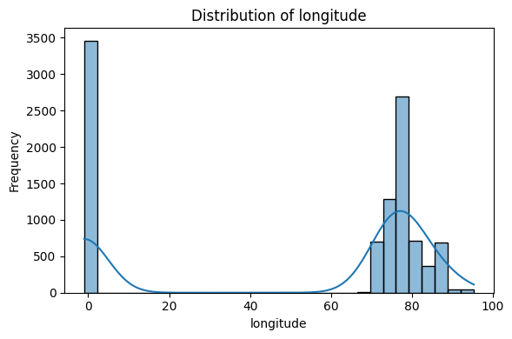

[Figure: EDA —Histogram of longitude]

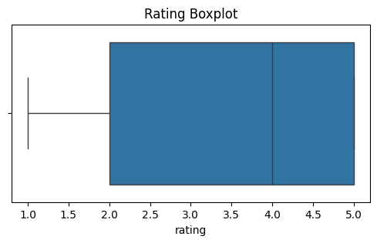

[Figure: Boxplot of rating]

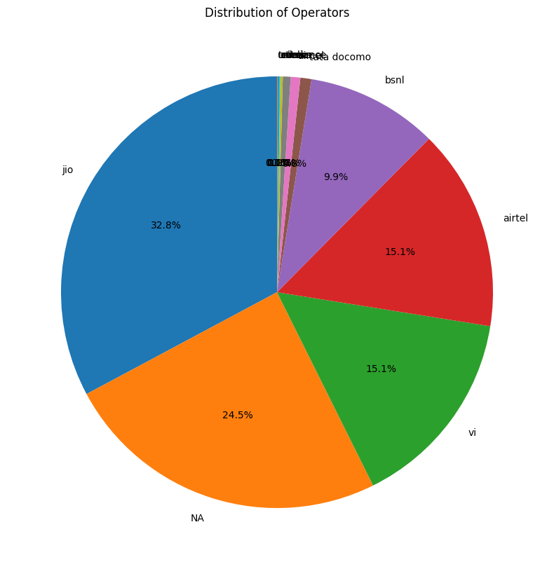

[Figure: Pie chart of Operators]

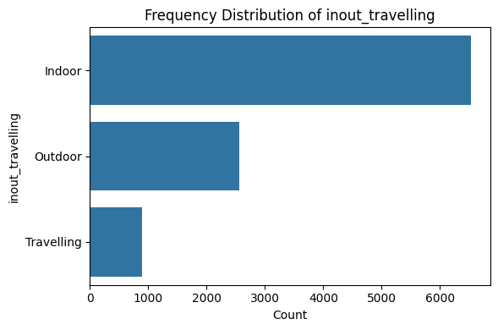

[Figure: Frequency distribution of inout_travelling]

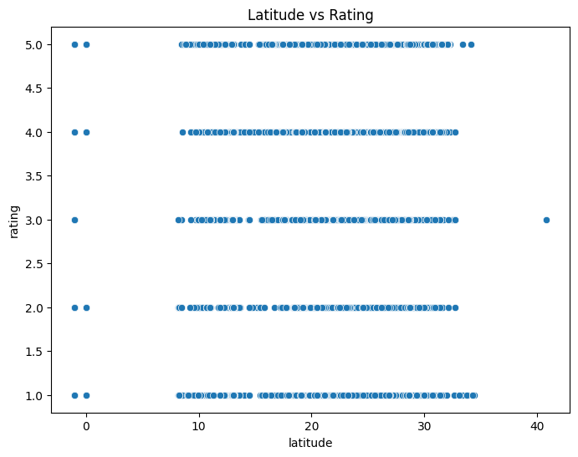

[Figure: Scatter plot of latitude vs Rating]

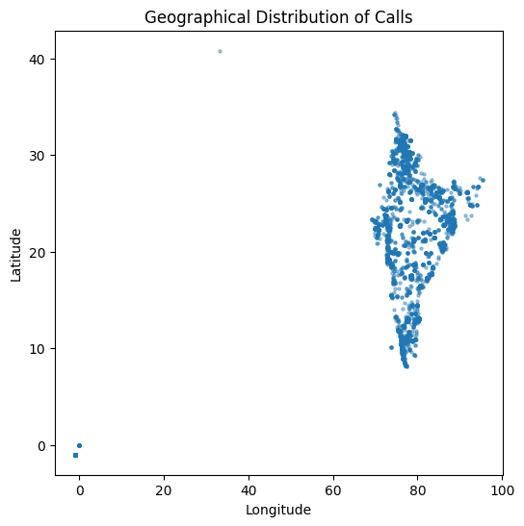

[Figure: Scatter plot of Latitude vs Longitude]

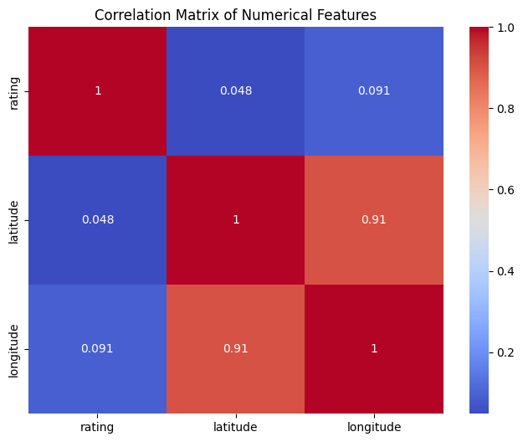

[Figure: Correlation Heatmap (Pre-Encoding)]

7.3 Train-Validation-Test Split
The dataset was split before any encoding or scaling was performed to prevent data leakage. A stratified random split allocated 60% of records to the training set, 20% to the validation set, and 20% to the held-out test set (random_state=42). All preprocessing transformers -PCA, encoders were fitted exclusively on the training fold and applied to validation and test folds.

7.4 Feature Engineering
Latitude and longitude were standardised using StandardScaler present in scikit-learn and reduced to a single principal component via PCA (geo_pc1), which was appended as a new feature. A rule-based geo_region feature was derived from state names, mapping each state to one of five broad geographic regions: North, South, East, West, or Central. The calldrop_category column was ordinally encoded with a semantically meaningful ordering (Call Dropped = 0, Poor Voice Quality = 1, Satisfactory = 2) and fitted on training data. Additionally, nominal categorical features such as operator, inout_travelling, network_type, and state_name were one-hot encoded, with operators appearing in fewer than 1% of training records grouped into an 'Other' category. A post-encoding correlation heatmap was generated to verify that no strongly collinear feature pairs remained.
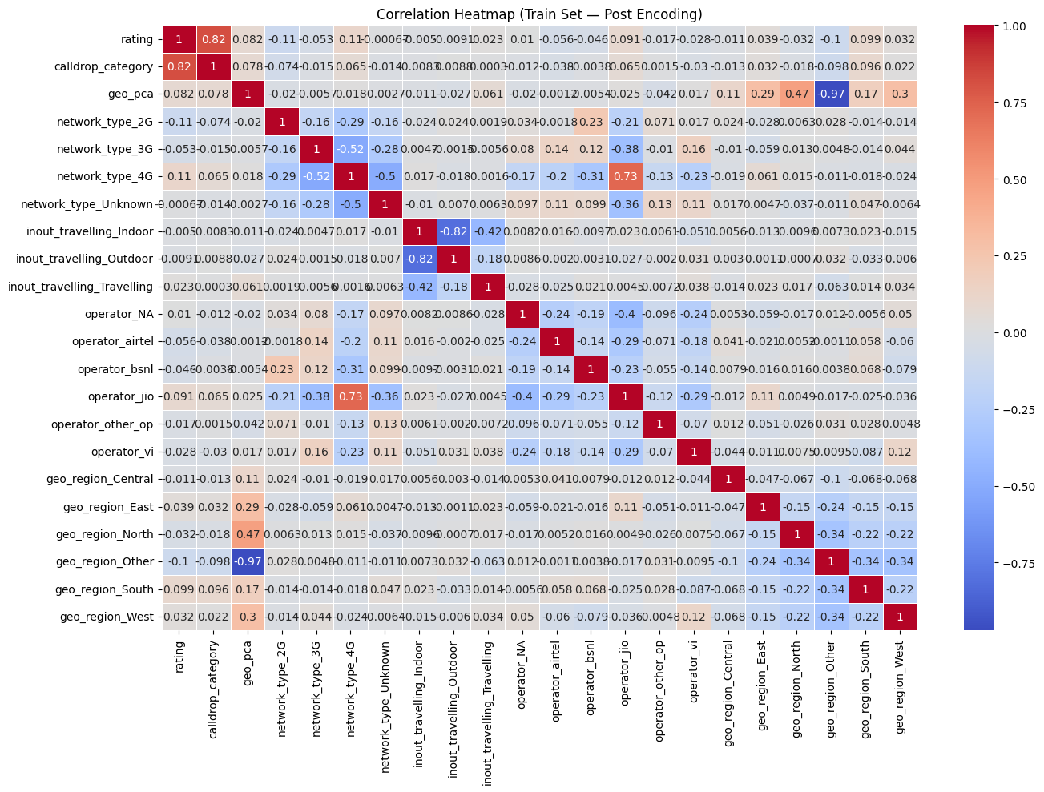

[Figure: Correlation Heatmap (Post-Encoding)]

7.5 Random Forest Model
A RandomForestRegressor was trained with 300 estimators, maximum tree depth of 12, minimum samples per leaf of 5, and square-root feature subsampling at each split. Five-fold cross-validation was performed on the training set which is used to estimate generalisation performance. Validation set predictions were generated for ablation comparison, and in-sample training predictions were used to compute residuals for the residual-learning stage.

7.6 FT-Transformer Architecture
The FT-Transformer was implemented from scratch in PyTorch with a glass-box training loop. The FTTokenizer module projects numerical features (latitude, longitude) through a linear layer into a shared embedding space of dimension 32 and embeds each categorical feature via a learnable embedding lookup table. The resulting token sequence is passed through stacked Transformer encoder blocks, each consisting of multi-head self-attention (4 heads), residual connections, a position-wise feed-forward network, and layer normalisation. A linear regression head maps the pooled output to a scalar prediction.
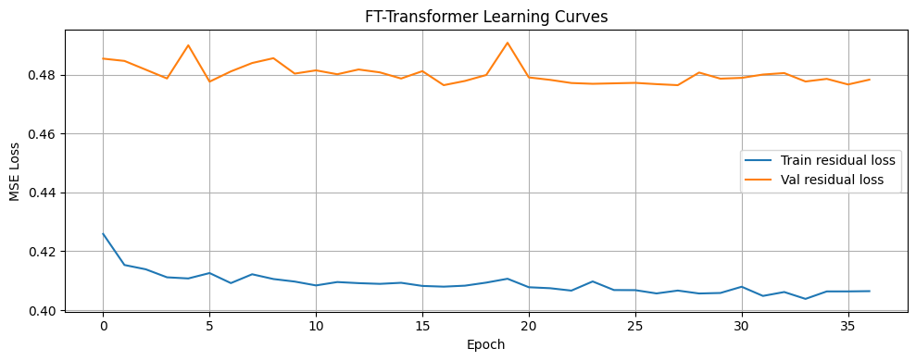

7.7 Residual Learning and Fusion
In the fused model architecture, the RF's in-sample training predictions were subtracted from the true labels to yield training residuals. A fresh FT-Transformer instance was trained on these residuals as the target, with validation residuals inspected each epoch. Early stopping with a patience of 20 epochs was also applied. The AdamW optimiser with a cosine annealing learning rate schedule (initial learning rate = 1e-3, weight decay = 1e-4) was used. The fused model prediction is the sum of the RF's prediction and the FT-Transformer's residual correction.

7.8 Standalone FT-Transformer
A separate FT-Transformer instance with identical architecture and training configuration was trained directly on the raw customer rating target (not residuals). This served as the standalone deep learning baseline in the ablation comparison, enabling a fair three-way evaluation: RF only, FT-Transformer only, and RF + FT-Transformer.
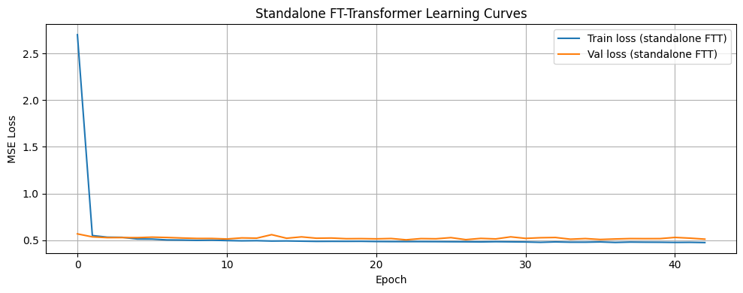

8. Results and Conclusions

8.1 Validation Set Results (Ablation Study)
Model | RMSE ↓ | MAE ↓ | R² ↑
Random Forest (RF) | 0.7006 | 0.6054 | 0.7725
FT-Transformer (Standalone) | 0.7098 | 0.6269 | 0.7665
Fused (RF + FT-Transformer) | 0.6902 | 0.5967 | 0.7792

8.2 Test Set Results (Final Evaluation)
Model | RMSE ↓ | MAE ↓ | R² ↑
Random Forest (RF) | 0.6970 | 0.6059 | 0.7774
FT-Transformer (Standalone) | 0.7048 | 0.6246 | 0.7724
Fused (RF + FT-Transformer) | 0.6876 | 0.5976 | 0.7834

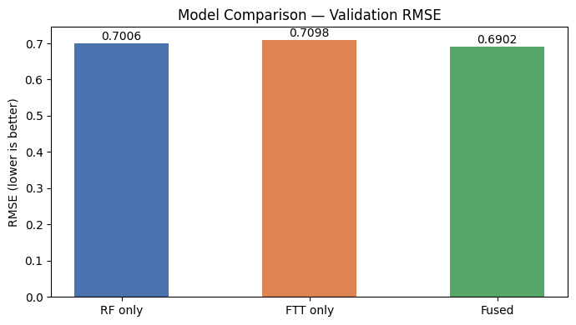

[Figure: Model Comparison of three models on Validation RMSE]

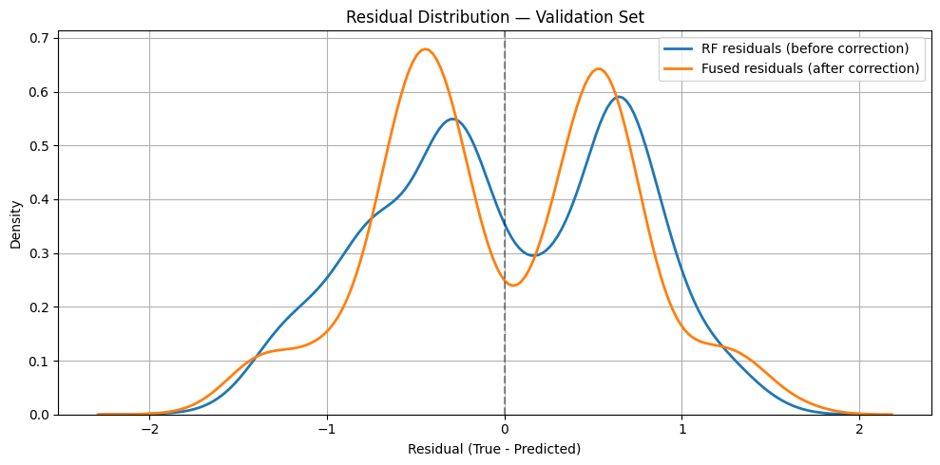

[Figure: Residual Distribution comparison on Validation Set]

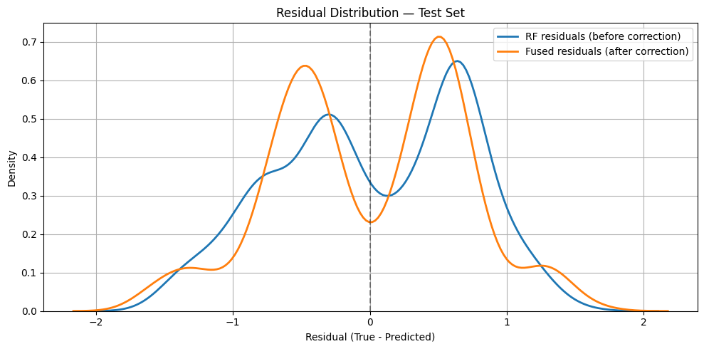

[Figure: Residual Comparison on Test Set]

8.3 Discussion and Conclusions
Across both the validation and test sets, the Fused model consistently outperformed its standalone counterparts on all the three metrics. On the test set, the Fused model achieved the lowest RMSE (0.6876) and MAE (0.5976), and the highest R² (0.7834), demonstrating that the FT-Transformer's residual correction meaningfully improves upon the RF's predictions and proving the capability of fused models.
Notably, the standalone FT-Transformer performed the weakest of the three models, trailing even the Random Forest model across all metrics. This was consistent with the broader literature findings of Grinsztajn et al. (2022), which showed the ability of tree-based models to outperform deep learning on moderate-sized tabular datasets and proved our point. The FT-Transformer, when applied directly, appeared to struggle and match the RF's natural robustness on this structured dataset.
However, the fused architecture resolved this tension: by delegating the primary modelling task to the Random Forest and using the FT-Transformer only to refine residual errors, the system inherited the RF's strong baseline performance while also enhancing the transformer's capacity to capture feature interactions that the RF's axis-aligned splits may have missed during their training.
This project concludes that hybrid models combining tree-based ensembles with attention-based deep learning represent a promising direction for tabular regression tasks, particularly when the standalone deep learning component is insufficient on its own. The fused approach is practical, modular, and extensible to other datasets and domains.

9. Future Work
Several directions could extend and improve upon the findings of this project. Firstly, hyperparameter optimisation using tools such as Optuna or Ray Tune while covering number of attention heads, number of transformer layers, embedding dimensionality and learning rate schedules could attain further performance improvements. The current model architecture uses a fixed configuration informed by prior literature but not rigorously tuned to this dataset.
Secondly, the dataset used for this project spans a single month (September 2017). Access to longitudinal data covering multiple months and years would allow the study of temporal trends in Call Quality and enable time-aware modelling approaches. Consequently, incorporating external features such as population density, network coverage maps or infrastructure data could enrich the feature set and improve predictive accuracy.
Thirdly, the fusion approach could be extended using iterative boosting: rather than a single RF followed by a single FT-Transformer correction, multiple rounds of residual correction, each using a freshly trained transformer could be stacked, analogous to gradient boosting but with deep learning weak learners. Regularisation strategies such as stochastic depth or mixup augmentation could be created to prevent overfitting in these deeper fusion stacks.
Additionally, the FT-Transformer in this project is trained from scratch. Pre-training the transformer on related tabular datasets (transfer learning for tabular data) and fine-tuning on the call quality dataset could be investigated, particularly given the relatively small size of this dataset. Approaches such as TabPFN or SAINT offer alternative transformer-based baselines worth comparing against.
Finally, model interpretability analyses including SHAP (Shapley Additive explanations) values for the Random Forest and attention weight visualisations for the FT-Transformer can be performed to provide actionable insights for telecom operators to identify specific conditions (operators, states, network types) most associated with poor customer experience.

10. References
[1] Vaswani, A., Shazeer, N., Parmar, N., Uszkoreit, J., Jones, L., Gomez, A. N., Kaiser, Ł., & Polosukhin, I. (2017). Attention is all you need. Advances in Neural Information Processing Systems (NeurIPS), 30, 5998–6008.
[2] Gorishniy, Y., Rubachev, I., Khrulkov, V., & Babenko, A. (2021). Revisiting deep learning models for tabular data. Advances in Neural Information Processing Systems (NeurIPS), 34, 18932–18943.
[3] Grinsztajn, L., Oyallon, E., & Varoquaux, G. (2022). Why tree-based models still outperform deep learning on tabular data. Advances in Neural Information Processing Systems (NeurIPS), 35, 507–520.
[4] Breiman, L. (2001). Random forests. Machine Learning, 45(1), 5–32. https://doi.org/10.1023/A:1010933404324
[5] Telecom Regulatory Authority of India (TRAI). (2017). Voice Call Quality – Customer Experience Dataset. Government of India Open Data Portal. https://www.data.gov.in/resource/voice-call-quality-customer-experience-till-last-month

11. Appendix
Section-1 Dataset Extraction via API
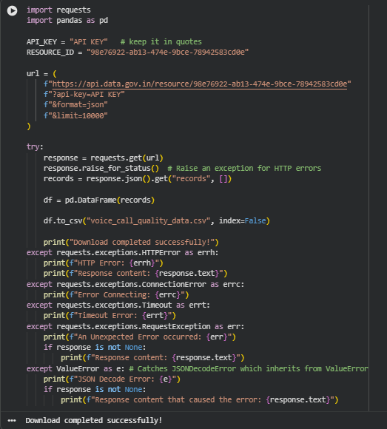

Section-2- Understanding the dataset
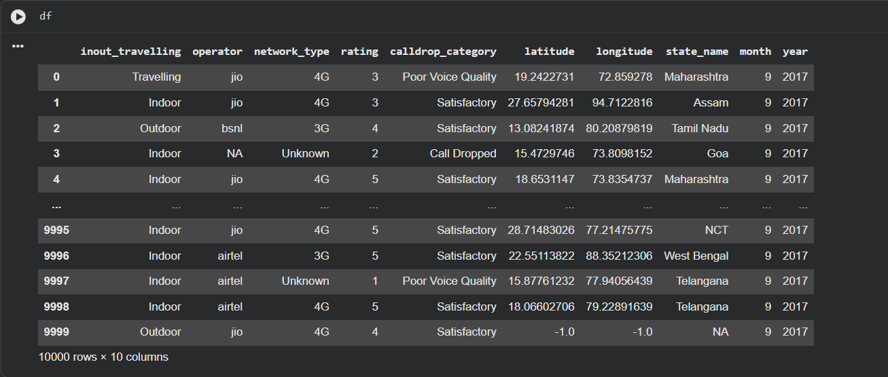

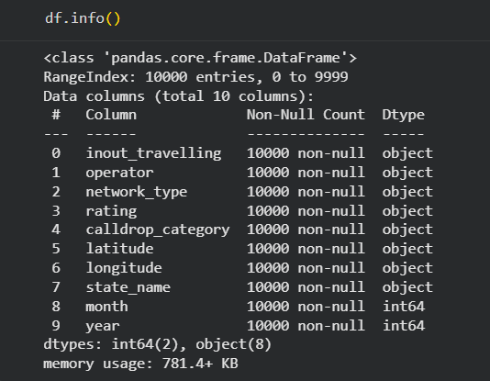

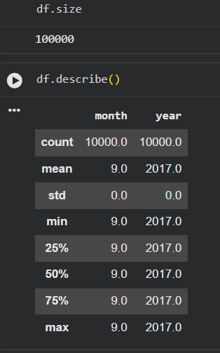

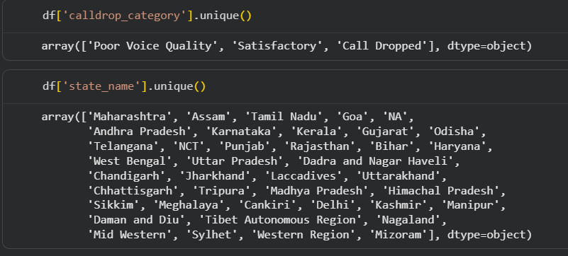

Section-4 Coerce Numeric Columns
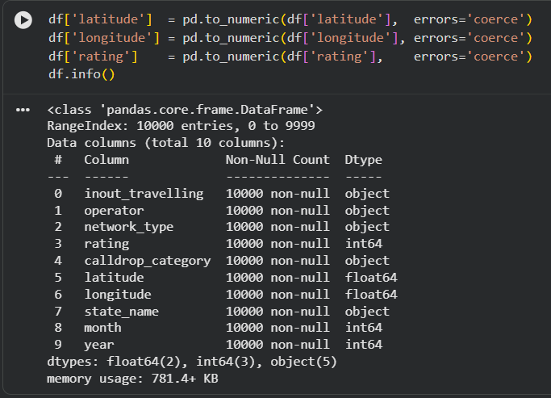

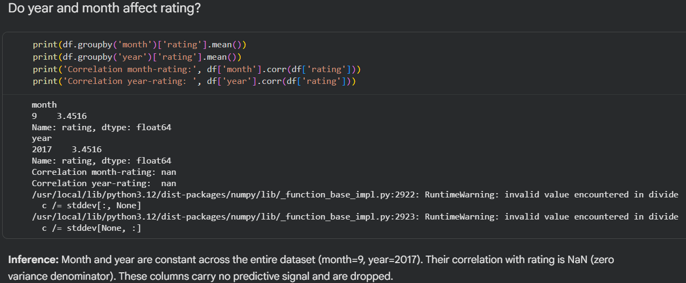

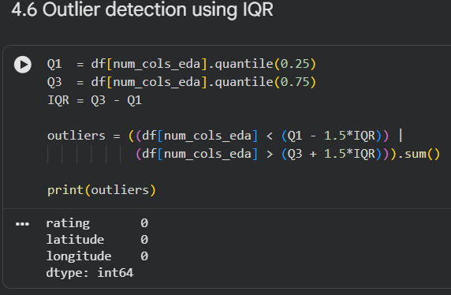

Section-5 Train-Test Split

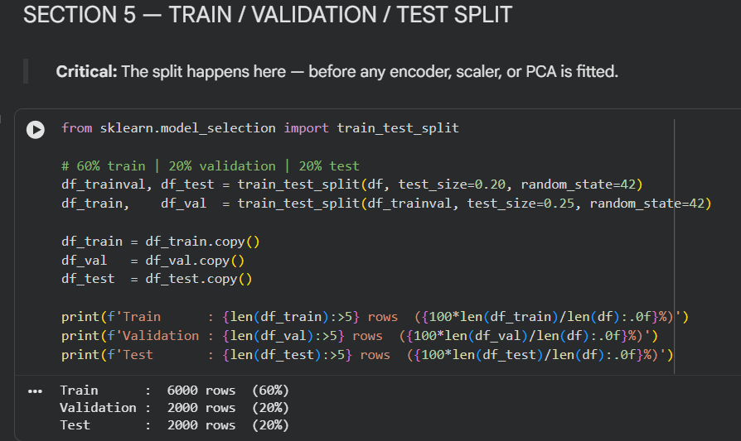

Section-6 Feature Engineering
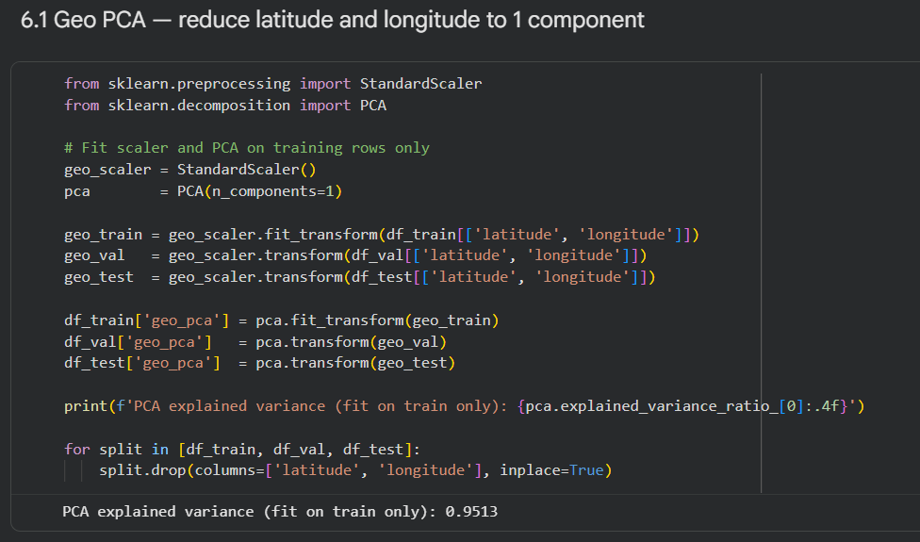

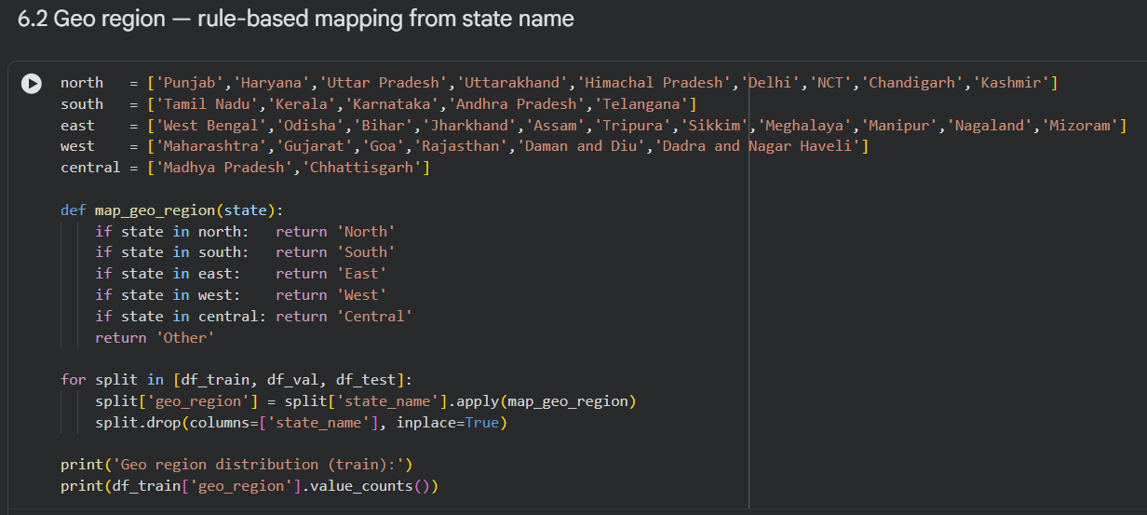

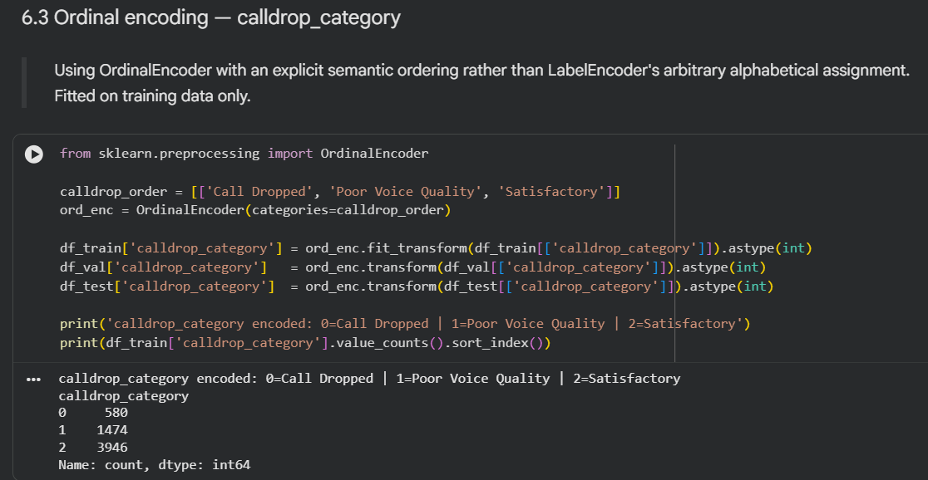

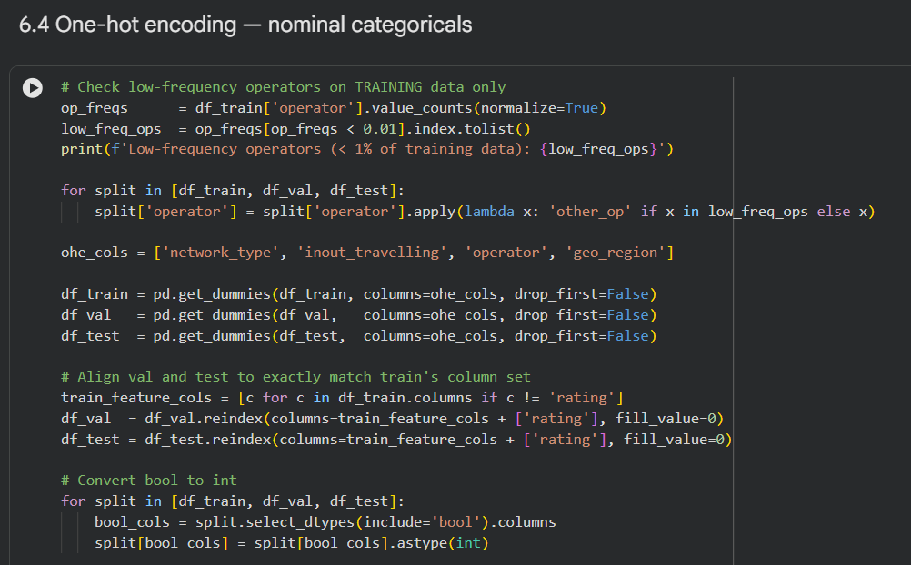

Section-7 Define X/Y Splits
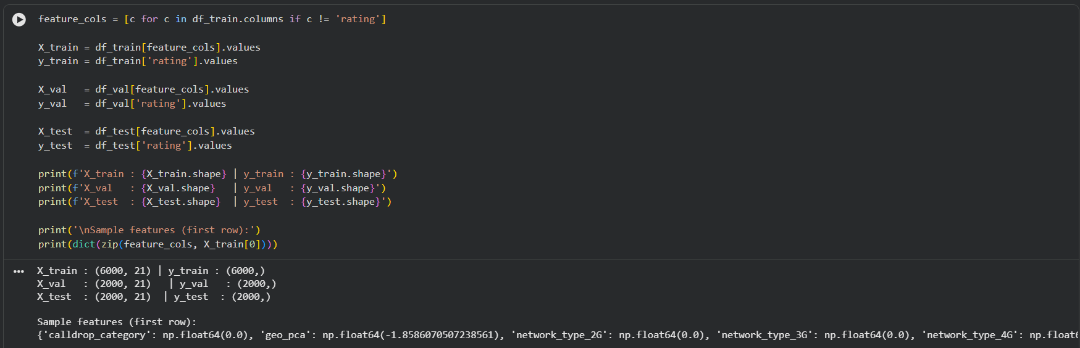

Section-8 Random Forest Baseline
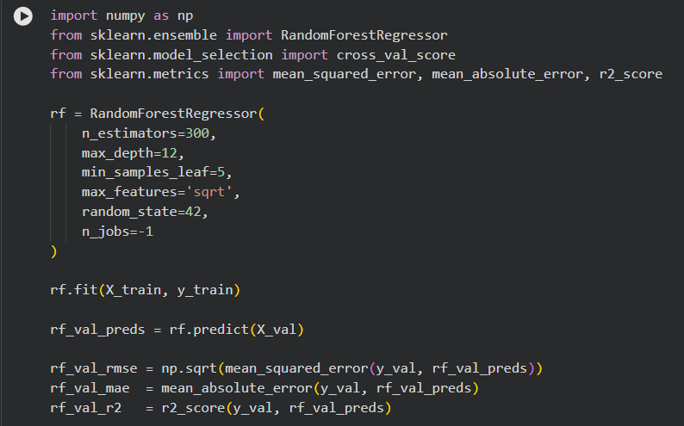

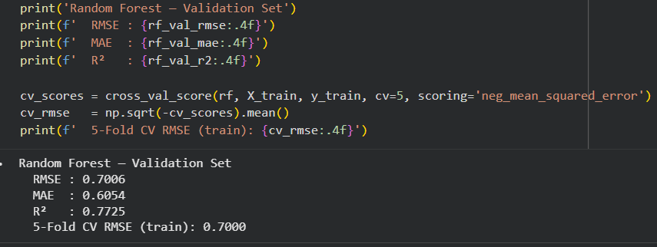

Section-9 Compute Residuals on Training set
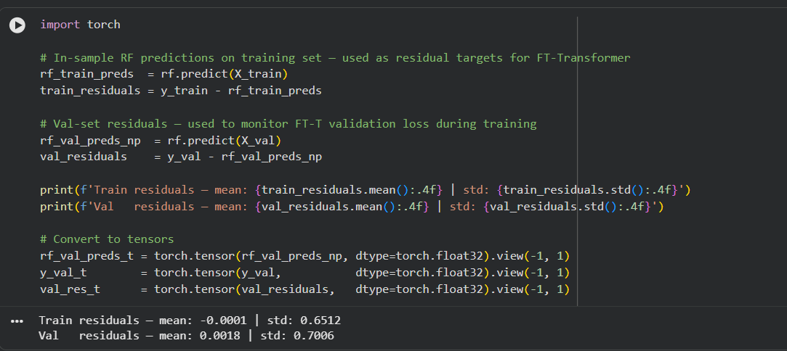

Section-10 Prepare Tensors for FT-Transformers
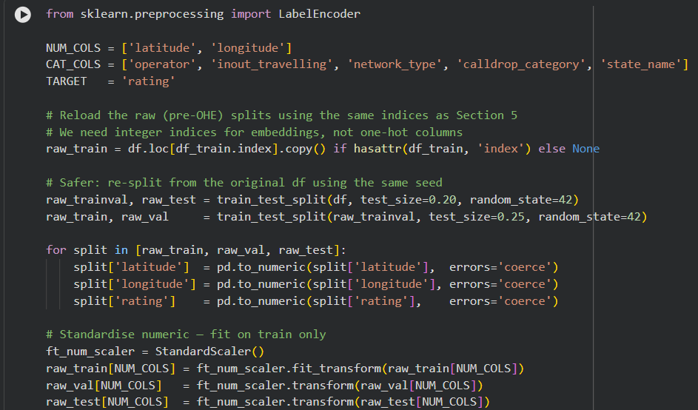

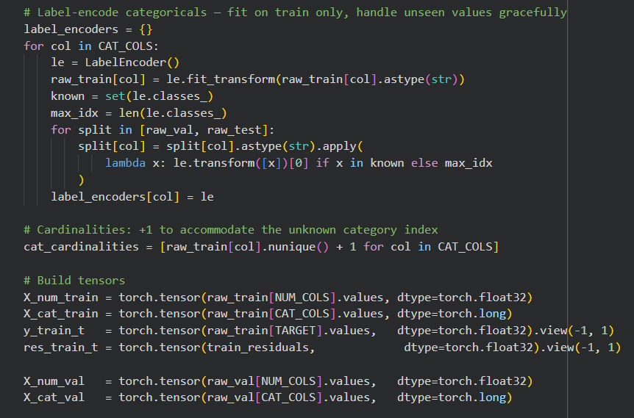

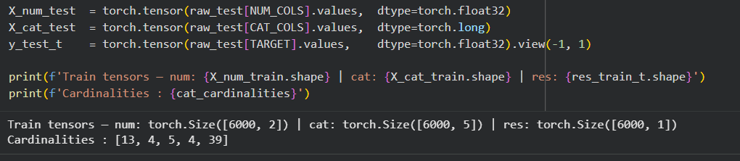

Section-11 FT-Transformers Architecture
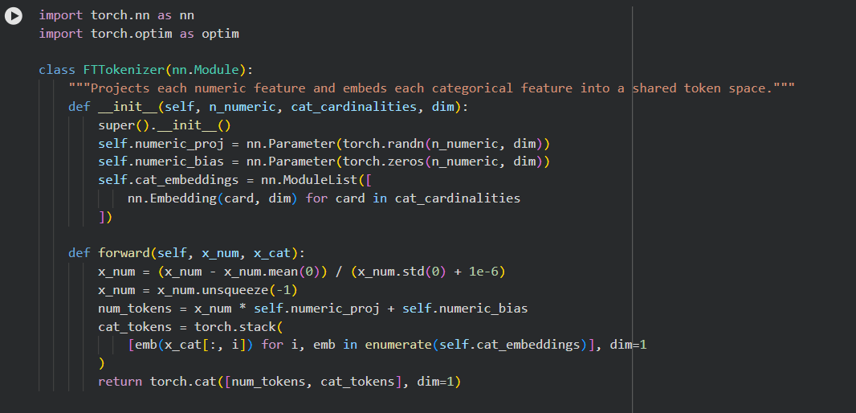
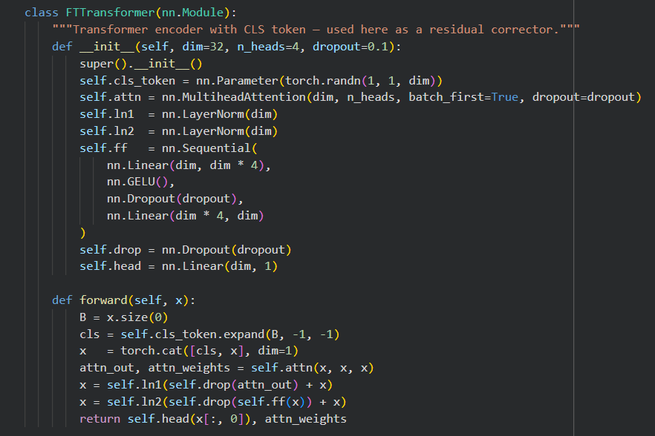

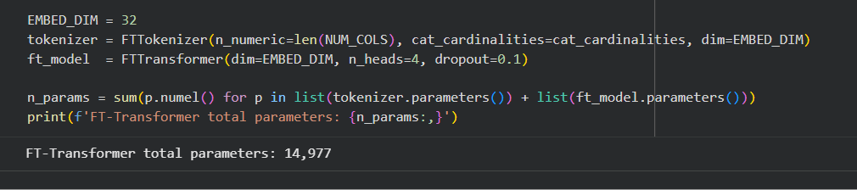

Section-12 Train FT-Transformers on Residuals
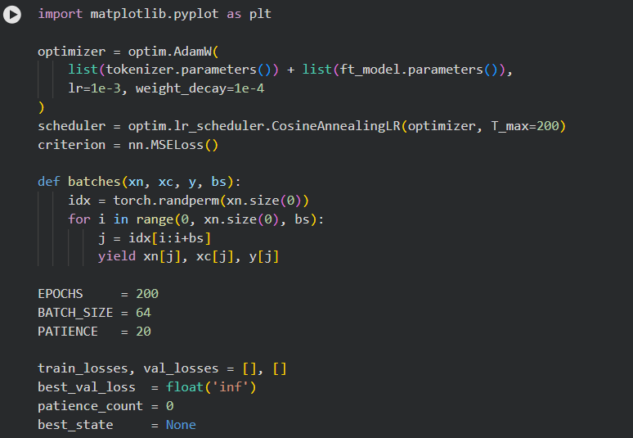

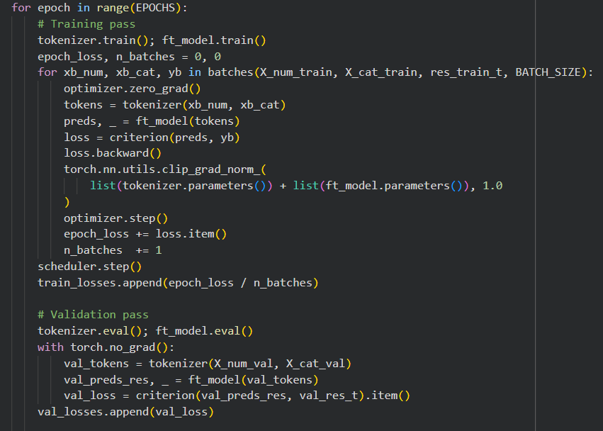

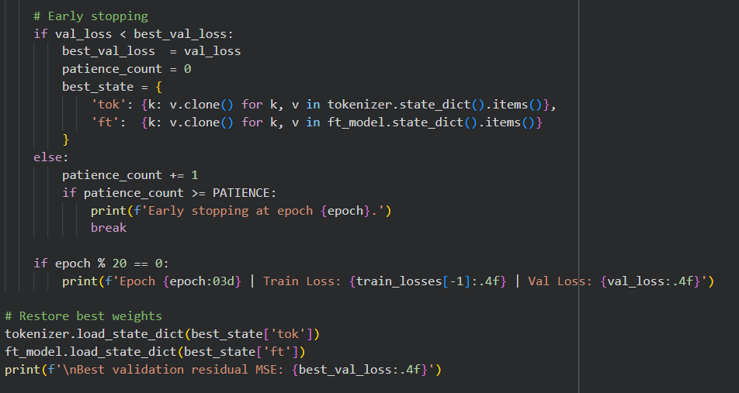

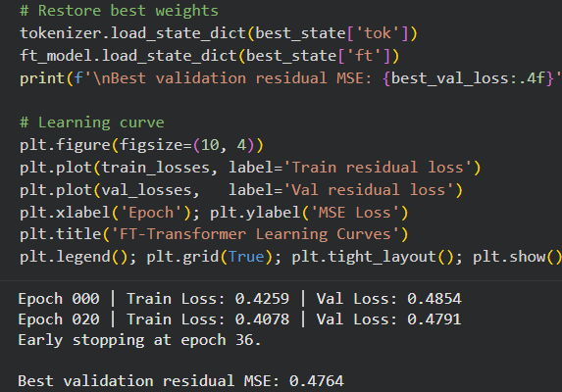

Section- 12.5 Train FT-Transformers (Standalone)

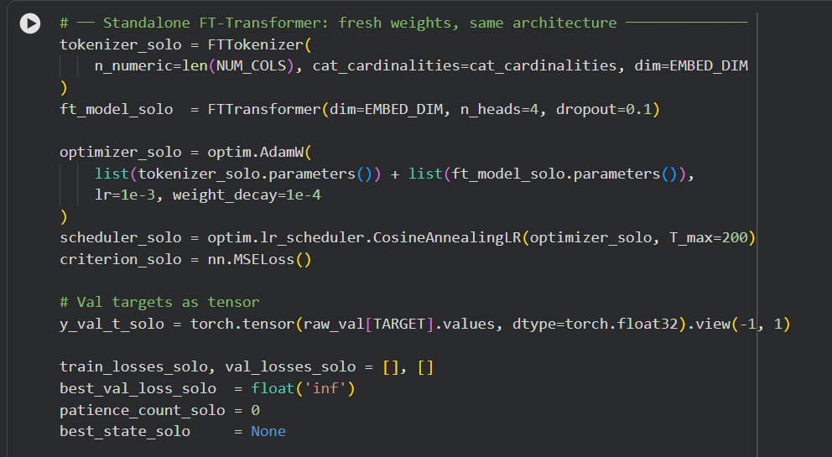

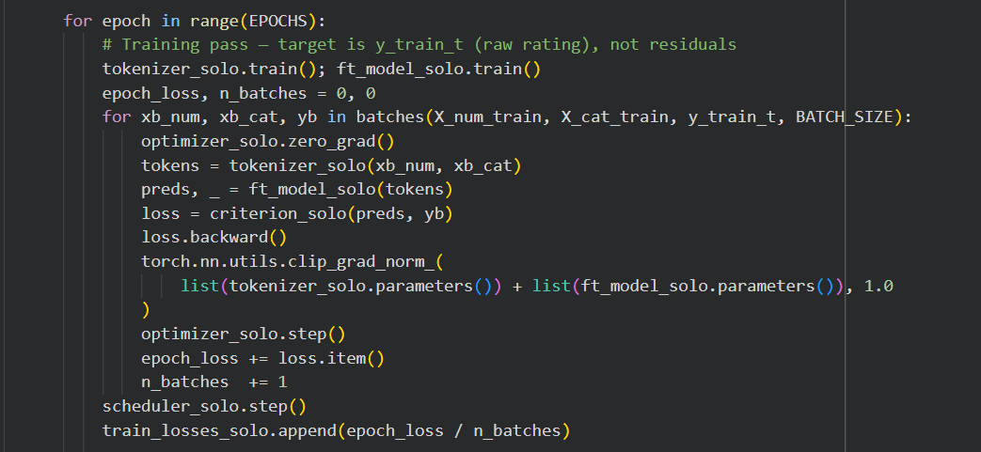

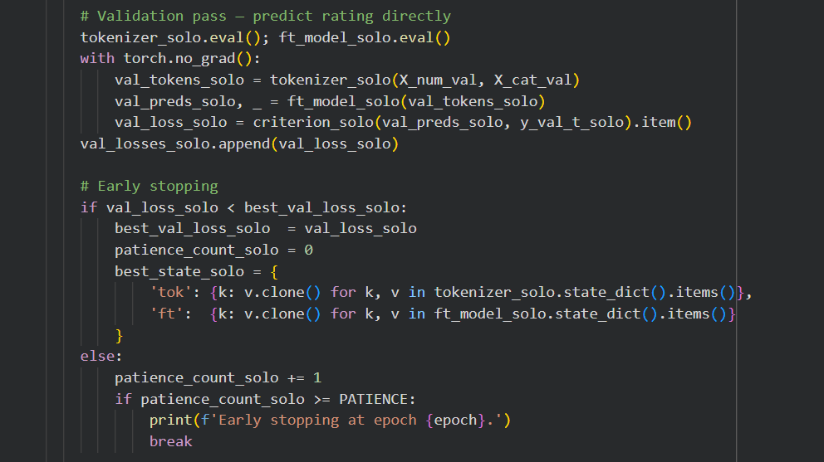

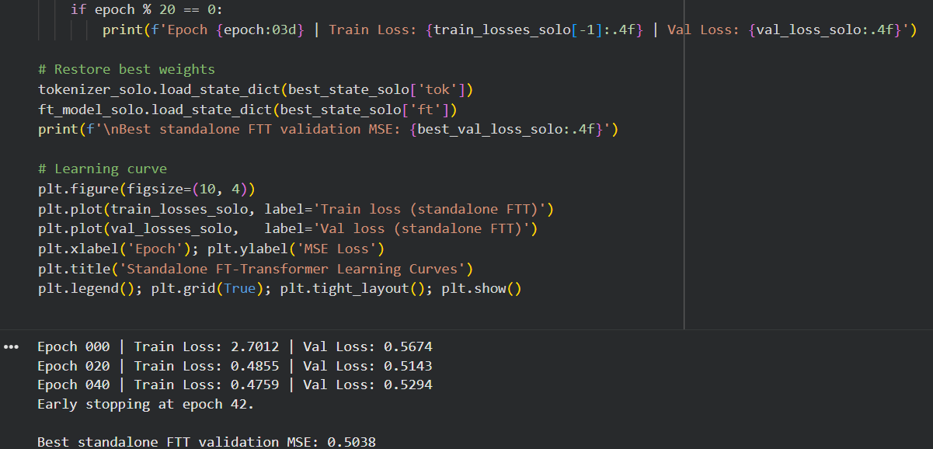

Section-13 Ablation Study
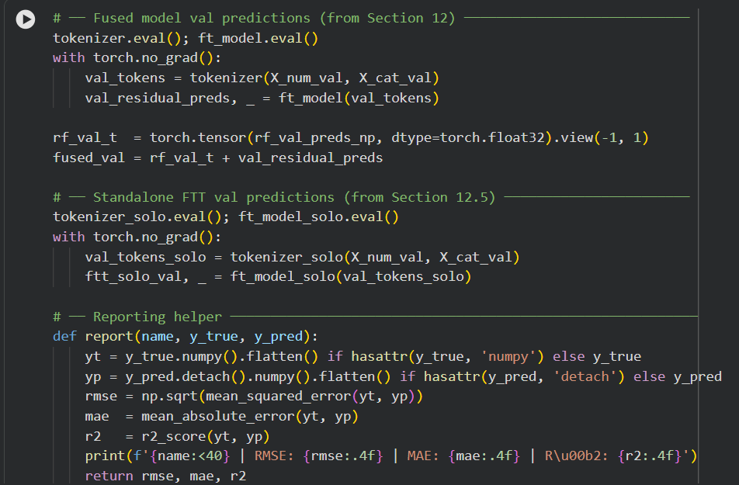
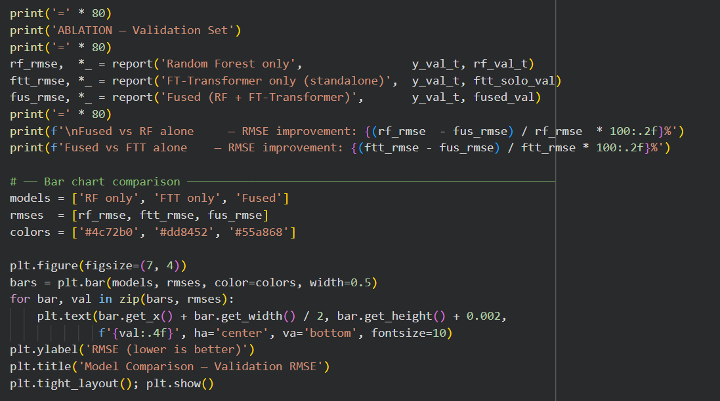

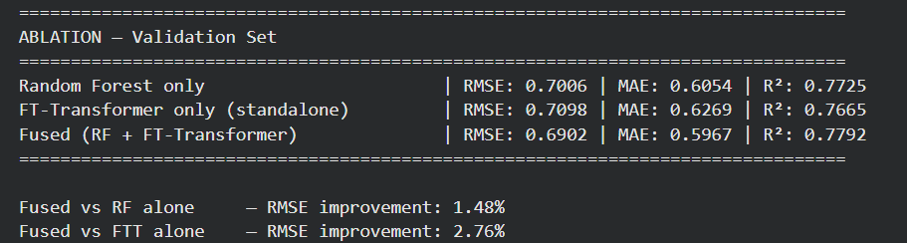

Section-14 Final Evaluation
